**Charlie Wall Mount**

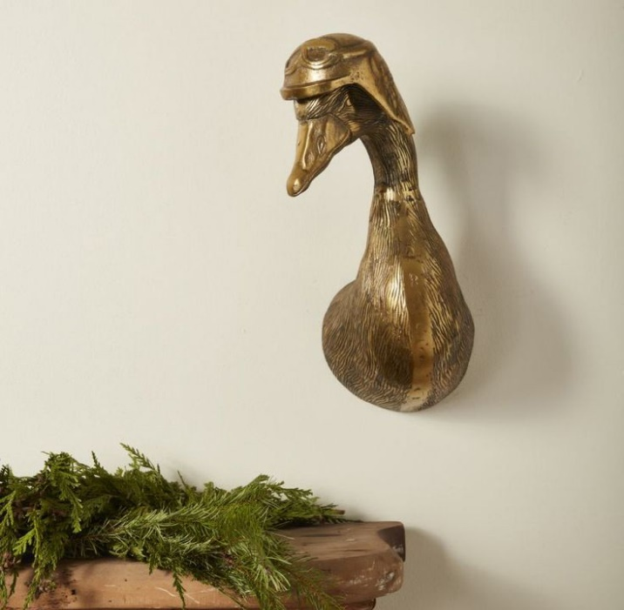The Charlie Wall Mount is a striking and unique decor piece that brings a playful yet refined touch to any space. Often designed to resemble an animal head, such as a deer, stag, or other wildlife, the Charlie mount features intricate detailing, capturing the essence of nature in a stylized way. With its clean lines and contemporary design, it blends well in various interior styles, from rustic to modern. Perfect for adding character and a bit of whimsy to a wall, the Charlie Wall Mount is an ideal choice for those looking to elevate their decor with a standout focal point.